CUSTOMER CHURN ANALYSIS REPORT

1. Introduction
This project mainly addressed issues related to predicting customer churn. The primary objective of the first phase of the project was to identify, take, and explore the dataset with relations to customer churn. The major element was to do the proper cleaning and preprocessing. This was followed by undertaking an EDA analysis. The final dataset is suitable for machine-learning model development. Customer churn is an essential element for understanding consumer behaviours that can make them either choose to continue with services or not. The results are then used to identify the best business recommendations for the company on reducing customer churn but improving consumer retention. The whole process was done in Python.

2. Data Gathering and Selection
Five datasets were provided and reviewed for relevance to churn prediction:

2.1 Customer Demographics
The demographics in the dataset were mainly age, gender, marital status, and income level. The primary rationale for considering the demographic characteristics is that they often influence customer behaviour and retention processes or patterns.

2.2 Transaction History
The transaction history is critical for this analysis. It includes elements such as spending habits, transaction dates, and transaction frequency. This is because spending behaviour and purchase frequency are strong characteristics that predict customer churn.

2.3 Customer Service Interactions
The interactions include interaction dates, interaction types, resolution status, and the number of unresolved cases. These elements are important because poor service experience is strongly connected to customer churn.

2.4 Online Activity
These are activities that customer engages in while using the services. For this dataset, we consider login frequency, platform use (either website, mobile app), and recency of access. These activities reveal the engagement levels of consumers, which in turn reflects on customer satisfaction.

2.5 Churn Status
The churn status is the primary target variable. It indicates whether each customer churned (represented by 1) or did not churn (represented by 0)

3. Loading Data and Data Merging
Data was loaded into python through separate sheets. The data from multiple sheets was merged using CustomerID as the unique key. Key transformations included:
- Cleaning CustomerID: this was stripped whitespace to avoid mismatches.
- Creating Transaction Summary Features. They include number of transactions, total amount spent, average spending, number of distinct product categories, first and last transaction dates
- Creating Service Summary Features
- Number of service interactions
- Number of resolved/unresolved issues
- Number of interaction types
- First and last interaction dates
- Joining All Data: A left join ensured all customers in demographics were retained.
- Filling Missing Data: Missing numeric values were replaced with zeros (e.g., no transactions = 0). Date fields were left as NaT for interpretation.

The final merged dataset contained:
- 1000 customers
- 21 features
- A mix of demographic, behavioural, transactional, and service-related features

4. Exploratory Data Analysis (EDA)

4.1 Basic Structure and Data Types
- Shape: (1000, 21)
- 5 categorical columns
- 11 numeric columns
- 5 datetime features
- 668 non-missing values in interaction date columns

The missing values were then visualised using the heatmap below:
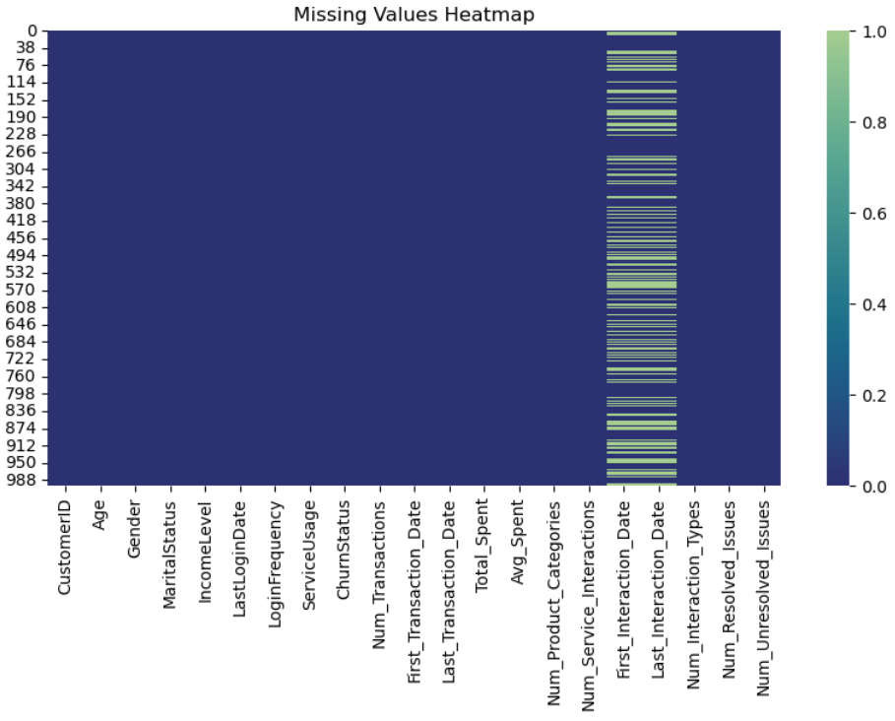

4.2 Univariate Analysis

4.2.1 Categorical Summary
- Gender. Mostly Female, although the gap is small.
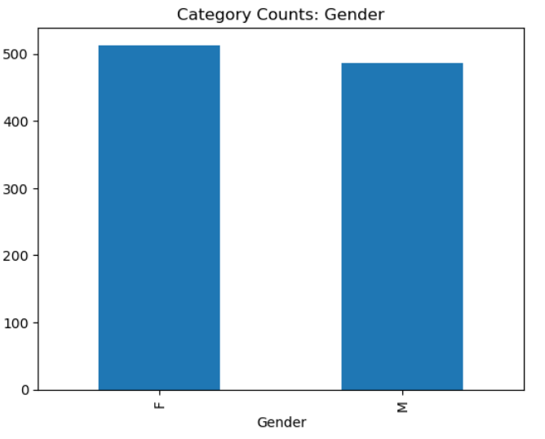

- Marital Status: Widowed most common, then married. Singles are the least
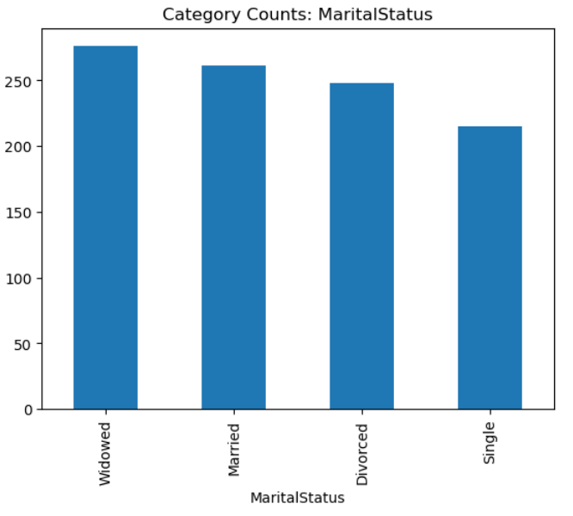

- Income Level: High-income group most common, medium and low income are similar.
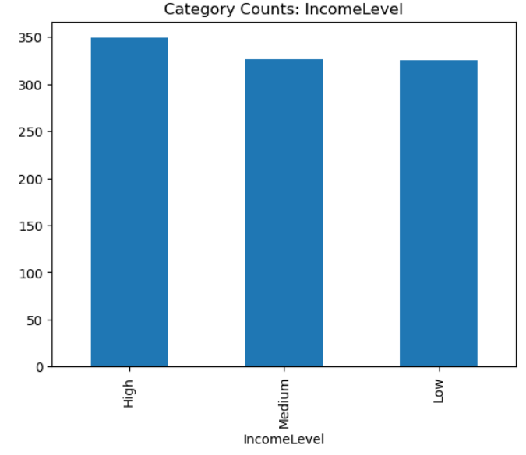
- Service Usage: Online banking and mobile app are higher than website.
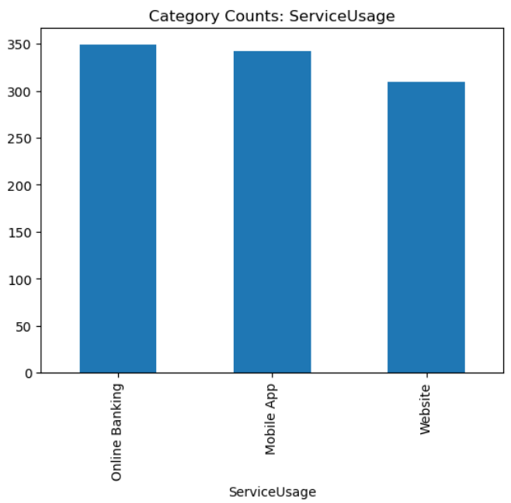

4.2.2 Numerical Summary
- Average age: 43 years
- Average login frequency: 26 logins
- Average total spending: £1267 (calculated in the mean of total output)
- Number of products: approx. 3 per customer
- Very few customers had service interactions (most customers have minimal or no service interaction).
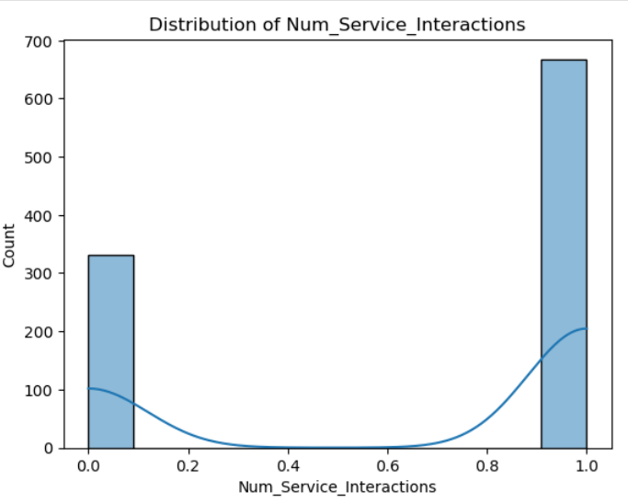
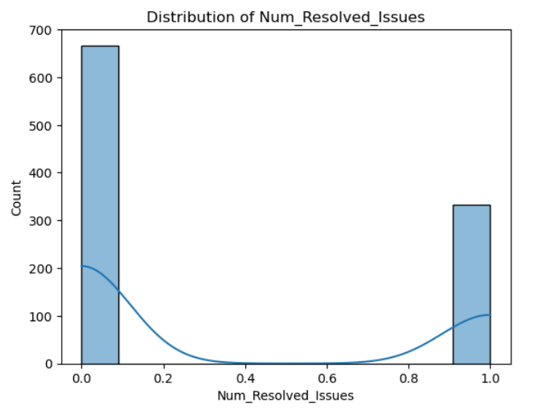
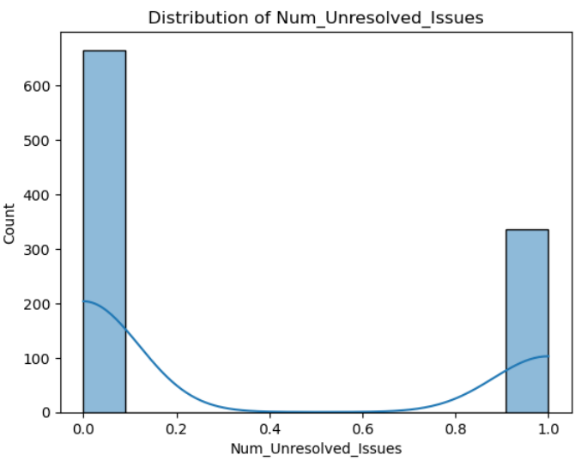

4.2.3 Target Variable (Churn Status)
- Churned: 204 customers (20.4%)
- Not churned: 796 customers (79.6%)
- This indicates class imbalance, which must be considered during modelling.
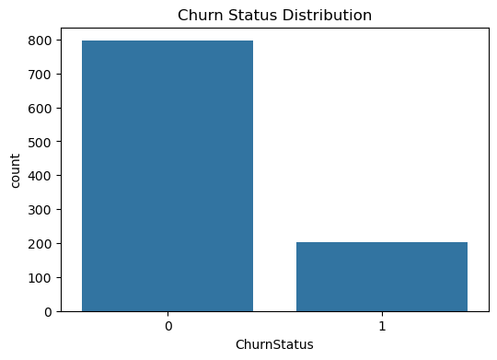

4.3 Bivariate Analysis

4.3.1 Categorical vs Churn
- Income Level: Higher churn among Low-income customers
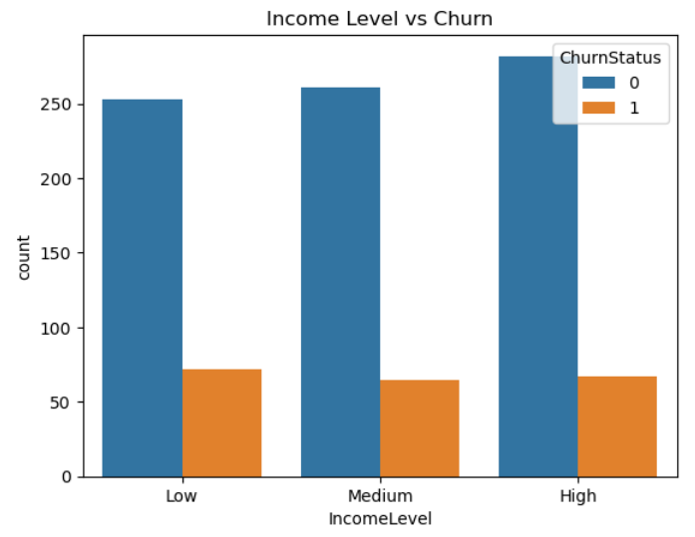

- Service Usage: Mobile App users churn slightly more
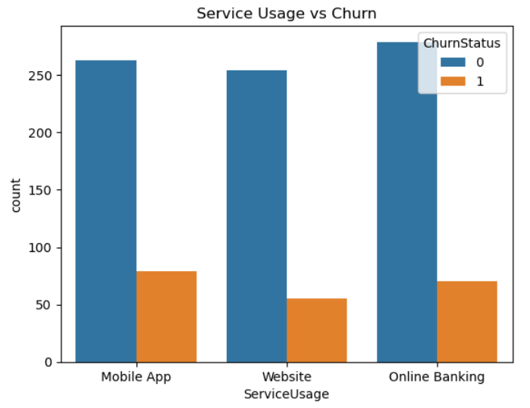
- Marital Status: Widowed customers churn more
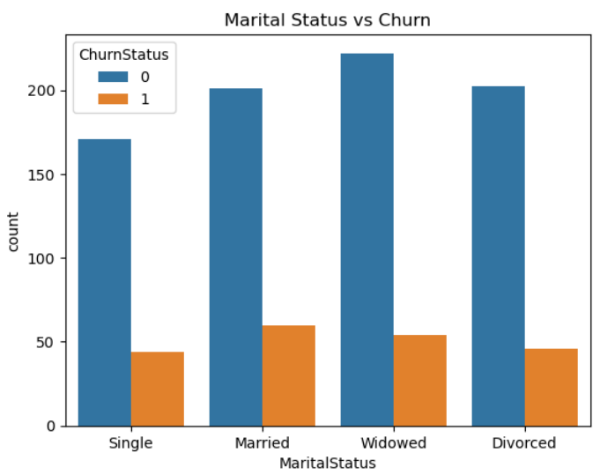

- Product Categories: Higher product engagement leads to lower churn
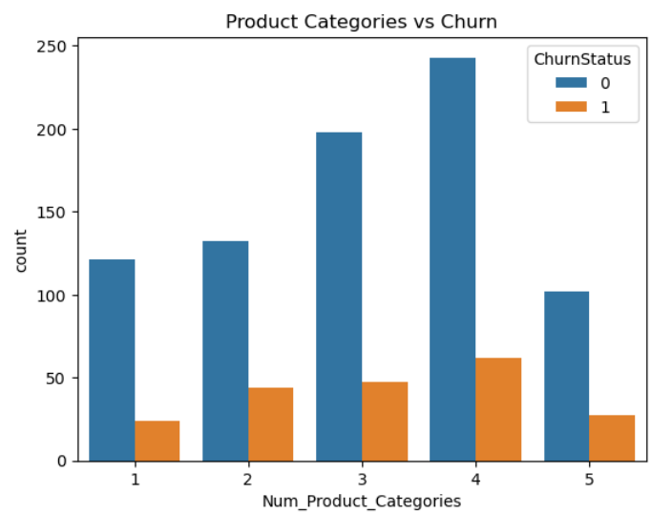

4.3.2 Numerical vs Churn
- Lower login frequency is associated with higher churn
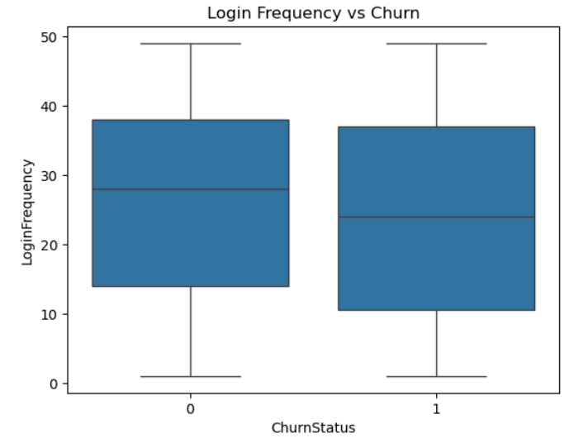
- Little difference in age between churned and non-churned
- Spending does not show strong separation between churn groups, although the median for those who churned is a bit lower than those who did not.
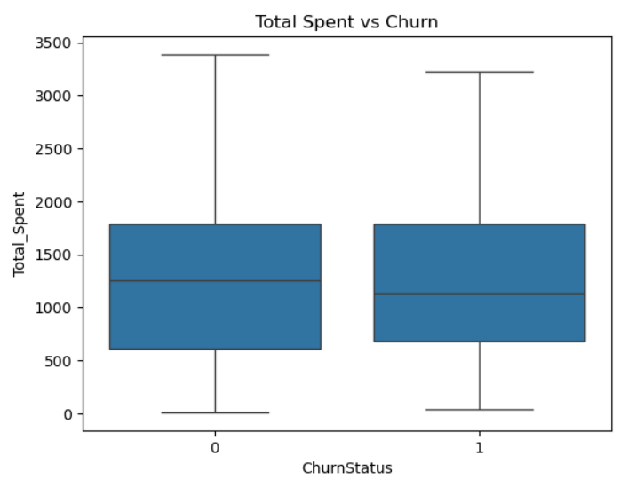

4.3.3 Recency Feature
A derived feature Days Since Last Login revealed customers who have logged in recently and those who didn’t have almost similar churn performance. Therefore, this is not a significant indicator for predicting churn status.
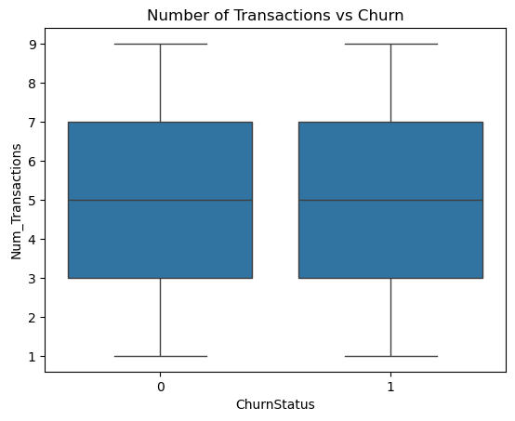

4.4 Multivariate Analysis

Correlation Heatmap
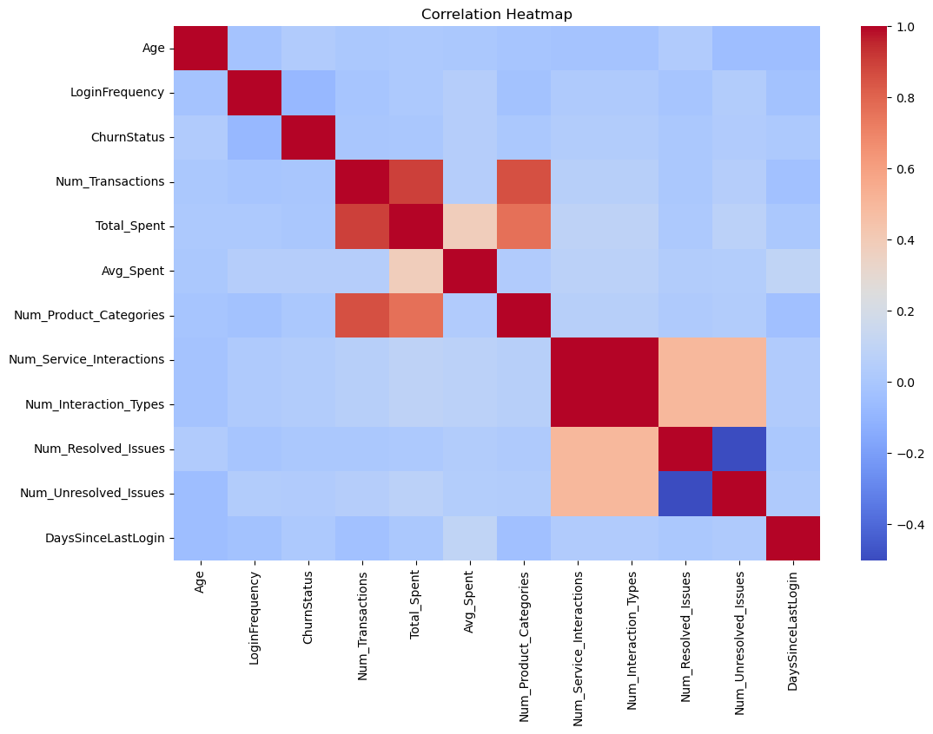

Correlations with ChurnStatus. strong correlations between:
- Num_Transactions and Total_Spent
- Num_Transactions and Avg_Spent
- Total_Spent and Avg_Spent
- Num_Service_Interactions and Num_Interaction_Types
- Resolved and Unresolved issues (weak negative)

Interaction Analysis
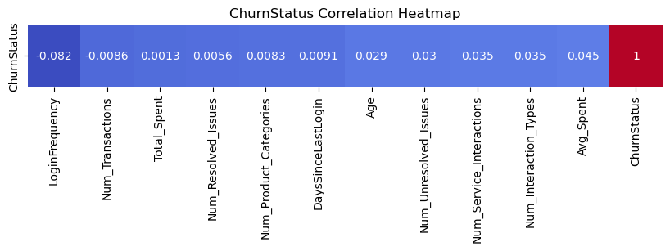

The ChurnStatus-focused correlation heatmap shows that all features have weak linear correlations with churn, with values close to zero. This is expected in churn prediction, where customer churn behavior is often driven by complex, non-linear interactions rather than simple linear relationships. The strongest (though still weak) relationships are with LoginFrequency (–0.082), suggesting that lower engagement increases churn risk, and Avg_Spent (0.045), indicating no strong direct spending–churn relationship. These results imply that advanced machine-learning models will be more effective than linear models for capturing churn patterns.

5. Data Cleaning and Preprocessing

5.1 Missing Values Handling
- Missing numeric features (e.g., service counts) filled with zeros
- Interaction dates left as NaT because they hold meaningful absence (no interaction)

5.2 Outlier Detection
- Spending had natural variation but no extreme outliers that required removal
- Transaction counts were bounded (no unrealistic values)

5.3 Standardisation / Normalisation
Not performed yet, but recommended before modeling for:
  - Total_Spent
  - Avg_Spent
  - LoginFrequency

5.4 Encoding Categorical Variables
For use in machine learning models, the following should be one-hot encoded:
- Gender
- Marital Status
- Income Level
- Service Usage

6. Final Prepared Dataset
- Total rows: 1000
- Total features: 21
- Fully merged, cleaned, preprocessed
The dataset is now ready for feature engineering and model development.

7. Conclusion
This report covered the entire data preparation pipeline. It started from data gathering and merging to exploratory analysis and preprocessing. The resulting dataset is clean, consistent, and suitable for building predictive models for customer churn. The insights gained from EDA indicate that customer engagement, service interactions, and usage behaviour are meaningful factors influencing churn.

